Wobbler kit onto trolley mounting

Parts list

4 x Nuts & bolts 4 x Short legs
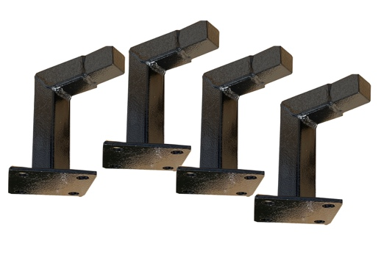
4 x M10 x 25mm bolts
4 x nylon locking nuts
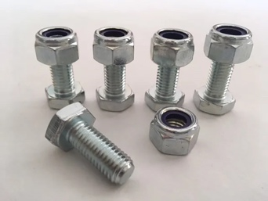

2 wheel trolley Wobbler kit
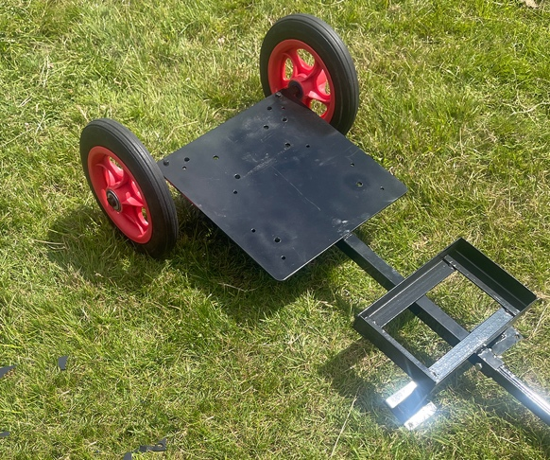
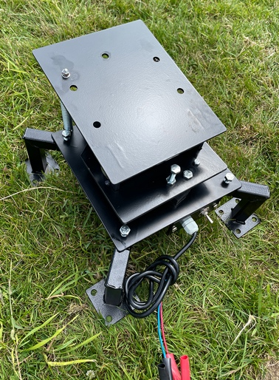

Step 1
Assemble the trolley

Attach the axle and fasten with the 2 x m10 x 40mm bolt with nylon locking nut.
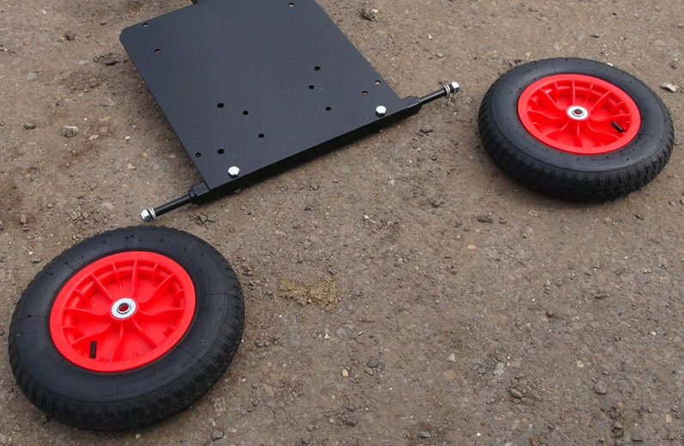

Slide the 2 x wheels onto the axle and fasten the m22 nylon nut onto the axle end thread.

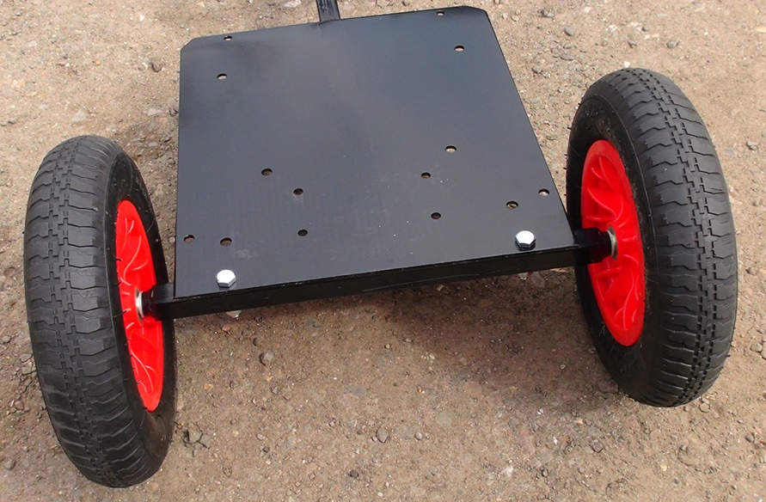

Step 2
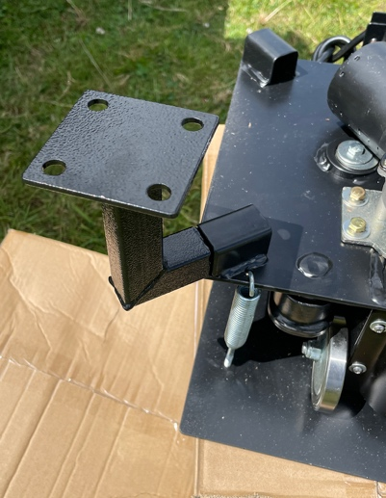
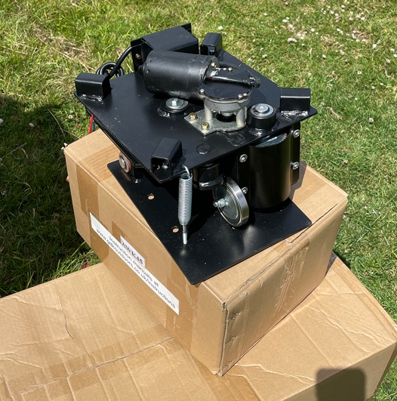
Attach the wobbler kit short legs
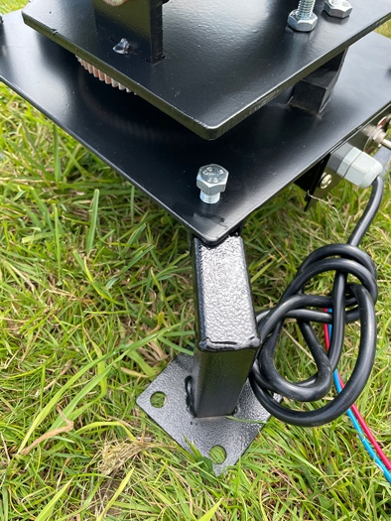
Attach the 4 x short legs onto the wobbler kit and nip the clamp bolt hand tight for now.

Step 3
Attach the wobbler kit to the trolley
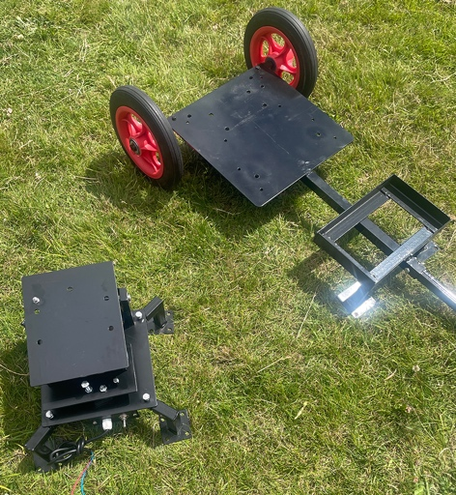
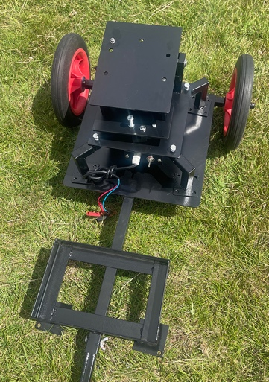

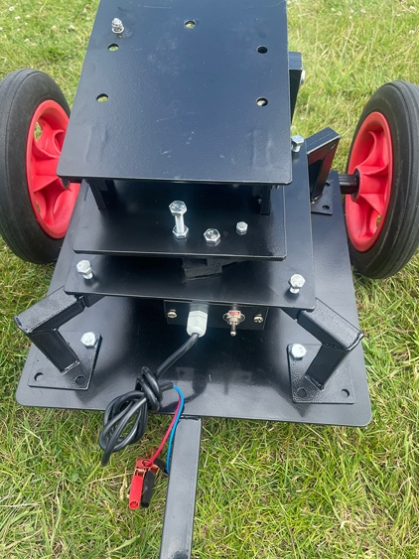
Mount the wobbler kit onto the trolley and align the pre-drilled holes. You may need to loosen the clamp bolts to align the holes.

Once you locate 1 x bolt per foot, tighten each foot nut and bolt, then tighen each clamp bolt holding the leg on. Do not over tighten.

